1. Create a Flask application with an /api route. When this route is accessed, it should return a JSON list. The data should be stored in a backend file, read from it, and sent as a response.

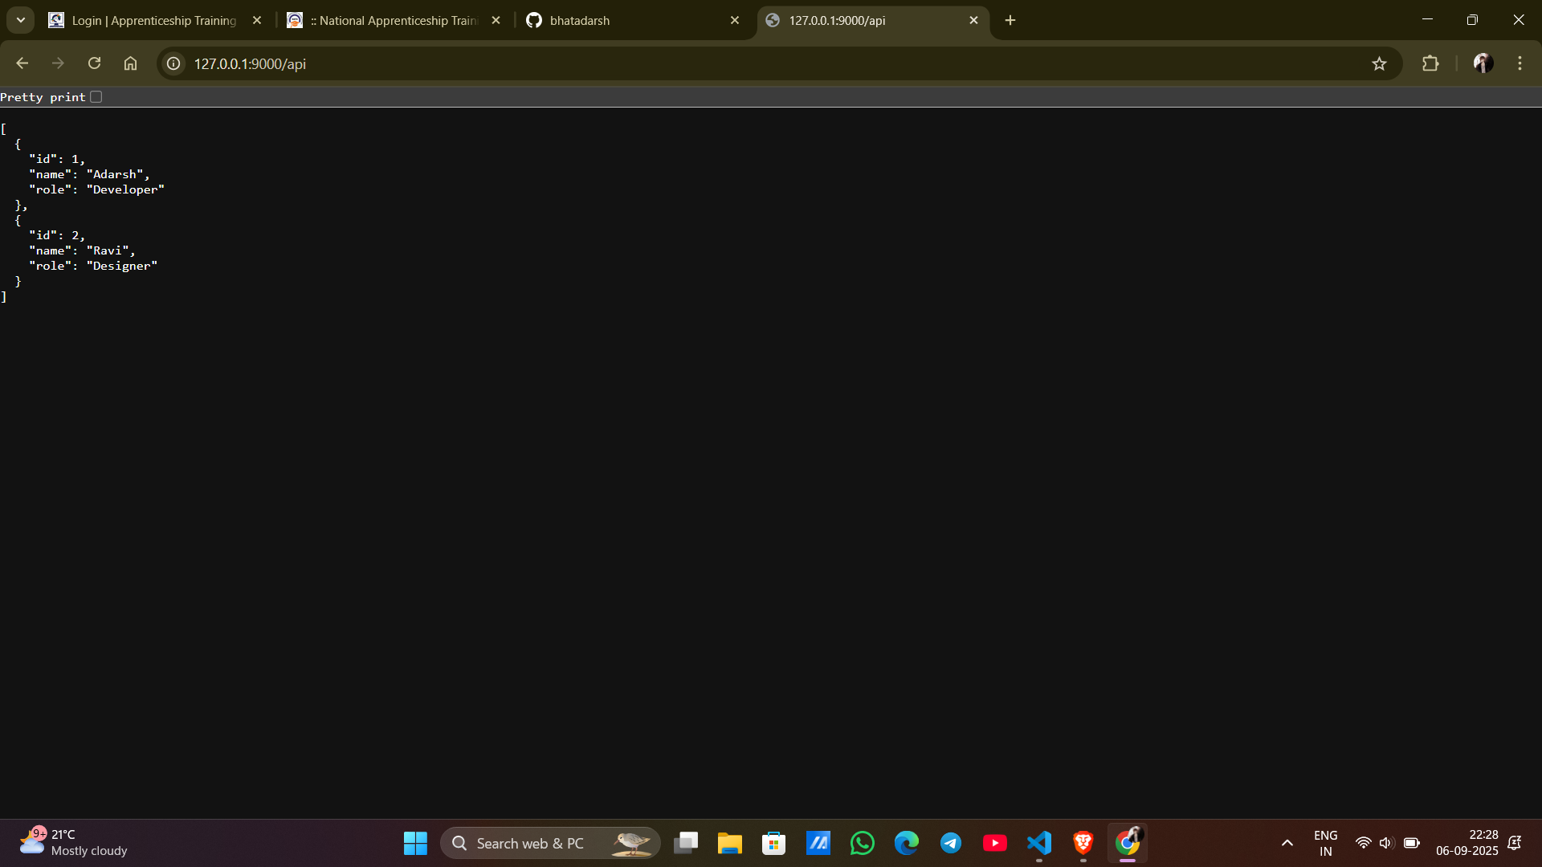

The backend Flask app (backend.py) exposes an **/api route** which reads data from a JSON file (data.json) and returns it as a JSON response.  
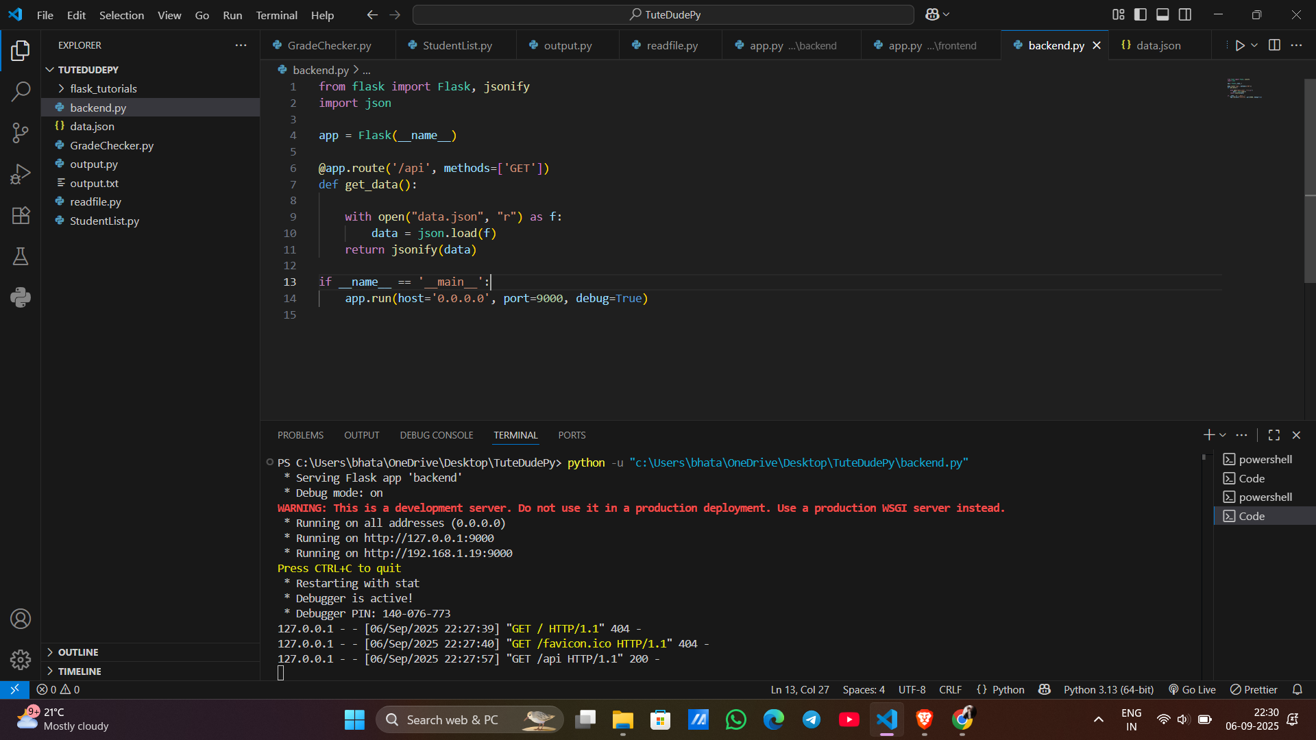

2. Create a form on the frontend that, when submitted, inserts data into MongoDB Atlas. Upon successful submission, the user should be redirected to another page displaying the message **"Data submitted successfully"**. If there's an error during submission, display the error on the same page without redirection.

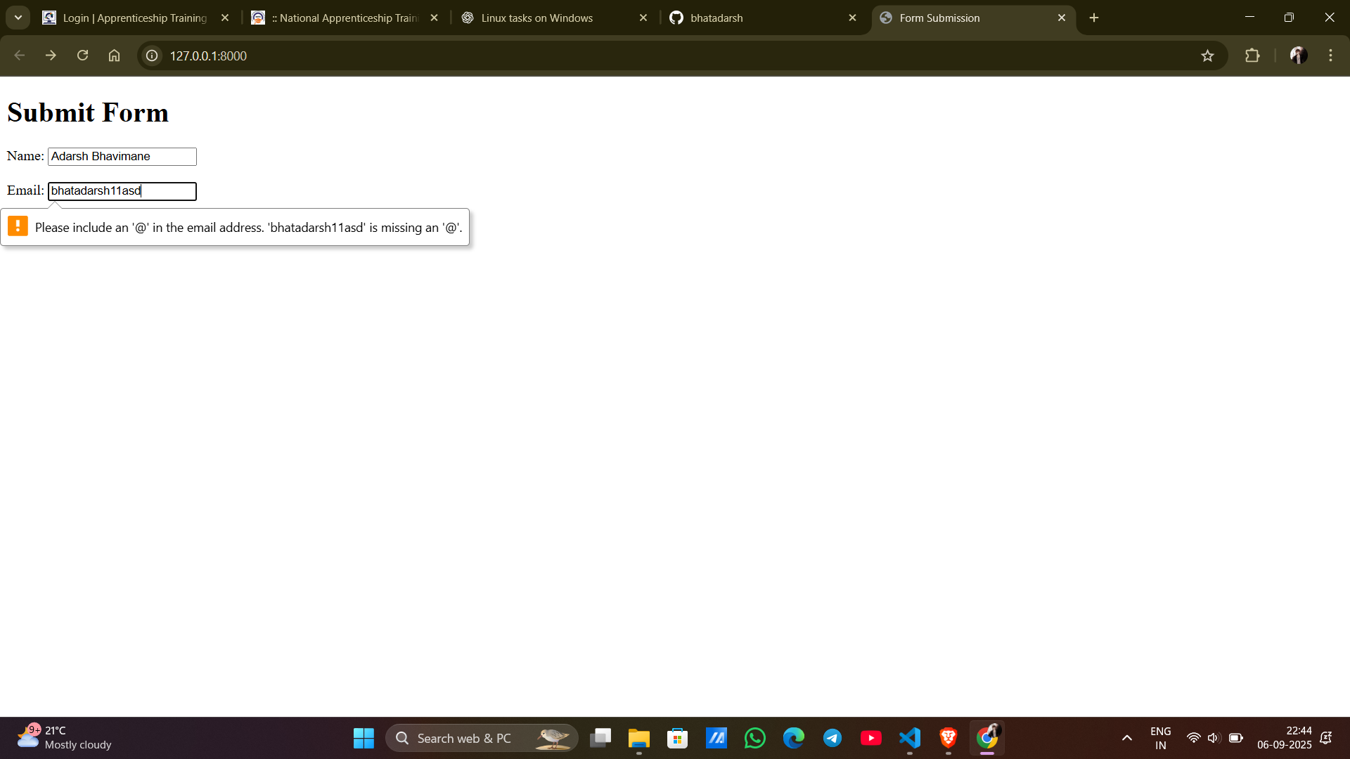

The frontend Flask app (frontend.py) provides a form to insert data int mongodb atlas. On success, it redirects to a confirmation page, while on error it shows the message on the same form page, I mean it shows what went wrong.  
And yeah so basically this 2 tasks shows api handling,mongo database integration and flask routing,yar TUTEDUDE is best❤️.

